Pypuppeteer

* What is Pypuppeteer
* Puppeteer is **a Node library that provides a high-level API to control headless Chrome over the DevTools Protocol**. Also known as a Headless Chrome Node API, it is useful for automating the Chrome browser to run website tests.

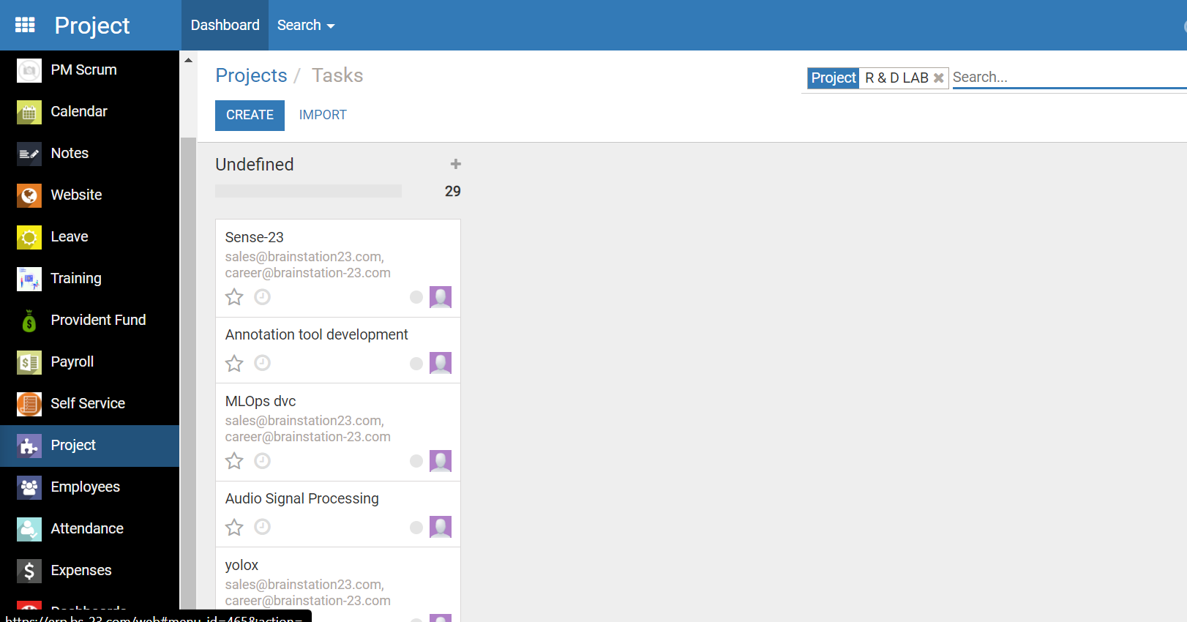

From erp we have to extract data from project, where each project contains several task, we use pypuppeteer to access project and get project list by using pypuppeteer through html contect ‘div>element>a’

We have to create env file having username and password of our erp

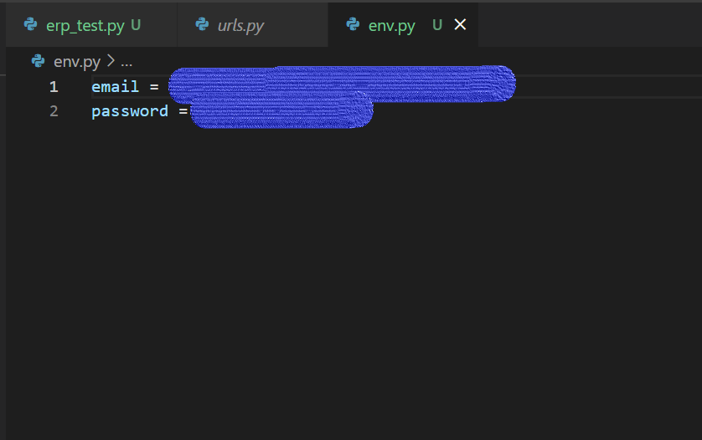

After giving password and email it will automatically login to erp site and fetch all project name and task from the project section

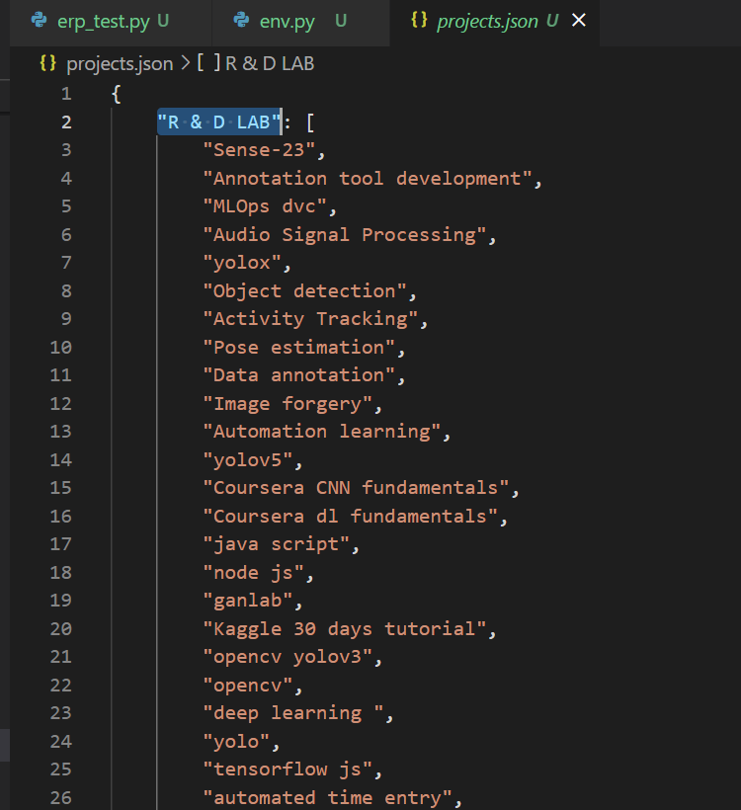

It will return a json file containing all its project list and task under the project